ECON 357 Assignment 2 (Version B)
This assignment is worth a total of 100 marks. Each question is worth 12 marks with the exception of question 8, which is worth 4 marks.

Prepare responses to the following questions in a single document. Make sure to show your calculations.

- A monopolist firm faces the following average revenue (demand) curve:

P = 120 – 0.02Q

Where Q is weekly production and P is the price, measured in cents per unit. The firm's cost function is given by TC = 25,000 + 60Q. Assume that the firm maximizes profits.

- What is the level of production, price, and total profit per week?

MR=MC

120-0.04q=60

60=0.04q

60/0.04 = q

1500=q

P= 120-0.02(1500)

P= 120-30

P=90

The price is 90 cents

Total profit = P*Q* -C(Q*)

(90) (1500) – (60) (1500) – 25000

= 20,000 Total profit is 20000 cents.

- If the government decides to levy a tax of 14 cents per unit on this product, what will be the new level of production, price, and profit?

MR=MC+t

T=14 cents

120-0.04Q=60+t

60 +14 =74

0.04q=120-74

0.04q=46

Q=1150

P=120-0.02(1150) -14

P=83

The price will be 83 cents

Total profit will be (p*q)*-C(Q*) = (83)(1150) –(60)(1150) -25000

= 1450 cents

- Suppose this firm is now operating in a perfectly competitive market structure. Calculate the price and quantity this firm will produce to maximize its profit.
In perfect competition MC= 60
P = MC
120 - 0.02*Q = 60
Q = (120 - 60)/0.02 = 3000
So, price, P = 120 - 0.02*3000 = 60
Q= 3000 units
P=$60

- (a) Graphically illustrate a perfectly competitive firm incurring a loss in the short run.
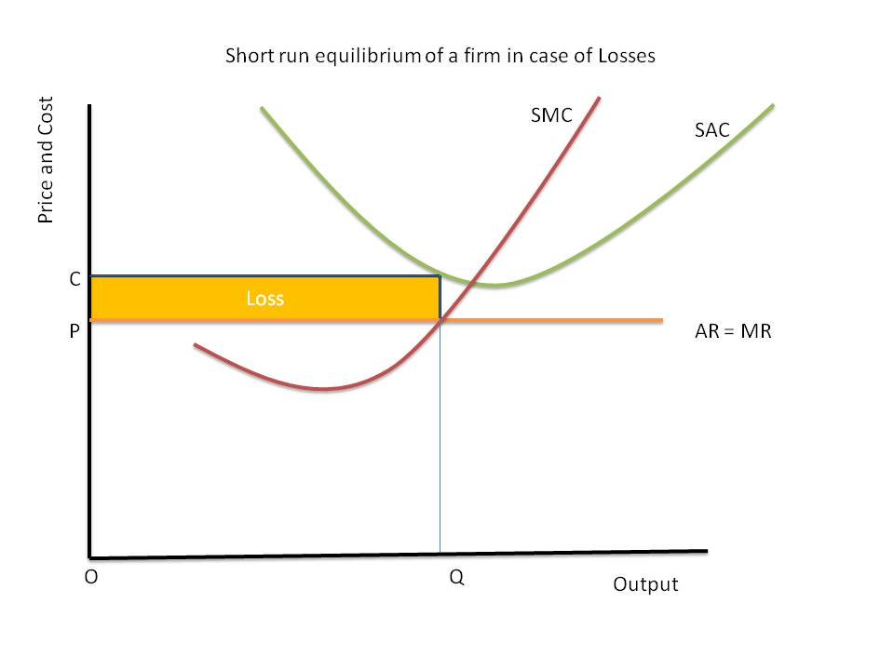
The graph above shows the firm is incurring the cost C to produce quality Q in the short run. The market price is price P, showing that the firm is experiencing a loss in the short run. The yellow area is the loss of the firm. OC is the firm's average cost, and OP is the revenue it gets in the short run.
(b) Explain what is meant by “shut-down determination” in the short run.
Shut-down is the maximum point where the firm experience maximum loss and it is not getting any revenue and decides to close all activities in the short run. Shut-down point the firm get revenue that cannot cover its fixed cost of the firm. Any activity beyond this point will increase the loss of the firm.

(c) If perfectly competitive firms incur a loss in the short run, graphically illustrate and explain the adjustments to long-run equilibrium.
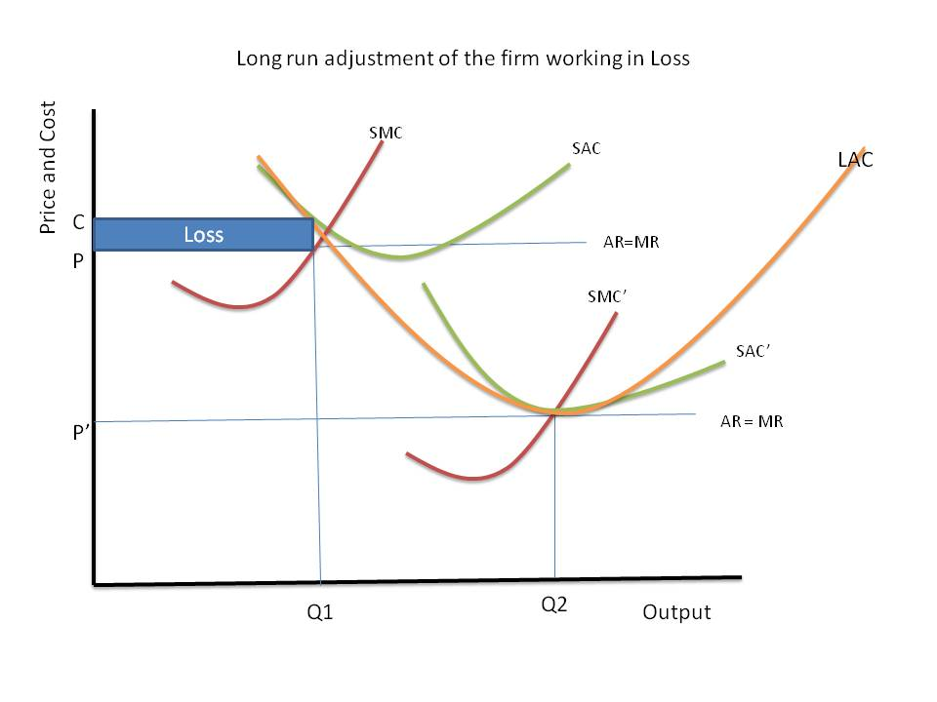
In the graph above, the firm operates at a loss in the short run at SMC through points AR and MR curve. The firm incurred cost C and sells its commodity at cost, leading to a loss.
In the long run, the firm can make new changes to minimize loss and increase the firm's profit. The new changes include effective transportation, finding new raw materials, and employing efficient machines. Some firms will leave the market due to making losses while the remaining firm will be breaking even. In the long run, if the firm average cost lowers, that price will be making a profit, and it will attract more firms in the market.

(d) Graphically derive and explain the long-run industry supply curve's underlying theory, assuming a constant cost industry.
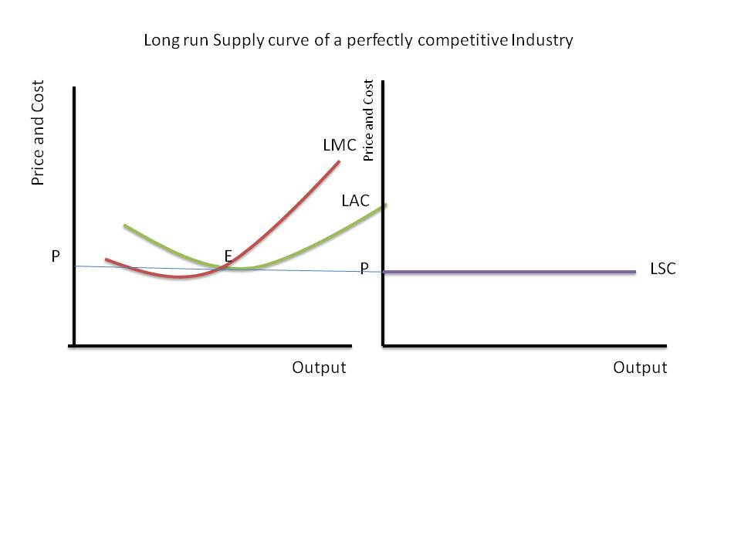
The graph shows that in the long run, the firm does not make any profit or loss. The firm can make sells as much amount of price where marginal cost meets with the average cost. Point R is where marginal cost meets with the average cost. This means that the firm can make sales at any point given price P.

- (a) If the government adopts a ceiling price on rental units, graphically illustrate and explain the effect on consumer surplus and producer surplus.

The government can use the price ceiling to control the prices of rental units in the country. A price ceiling is a maximum price the government can charge. The strategy can favor both the producers and consumers.
When the government decides to set a price ceiling above the market equilibrium price, there is no market effect. This is because the price ceiling above the equilibrium doe not change consumer surplus while the producers’ surplus will increase. When the government sets the price ceiling below the equilibrium, it will create a problem because the consumer's surplus will increase. In contrast, producers' surplus will decrease, which results in deadweight loss.

(b) Graphically illustrate the effect on consumer surplus and producer surplus if the government adopts a floor price for an agricultural good.
The price floor is the minimum price charged to the consumer by the producer. When the government uses a price floor on agricultural products, the producer’s surplus will increase, the consumer’s surplus will decrease.
When the consumer surplus decreases and producers surplus increases, it results in deadweight loss, and after the price floor, there will be excess supply and excess supply.

(c) Compare the impact of a ceiling price and floor price on consumer surplus and producer surplus.

The price ceiling causes a shortage of supply in the market. When the government uses a price ceiling, there will be a shortage of supply and excess demand. The price ceiling will cause insufficient allocation of resources in the economy. The price ceiling will also result in a deadweight loss due to producers' surplus shift to consumers' surplus.

Price floor causes the excess supply of the commodity in the market, which exceeds quantity demanded. When the government uses a price floor, there will be quality supplied will exceed the market's quality. The deadweight loss will also be experienced since part of the consumer surplus will shift to producers. Therefore, the price floor will cause a poor allocation of resources in society.
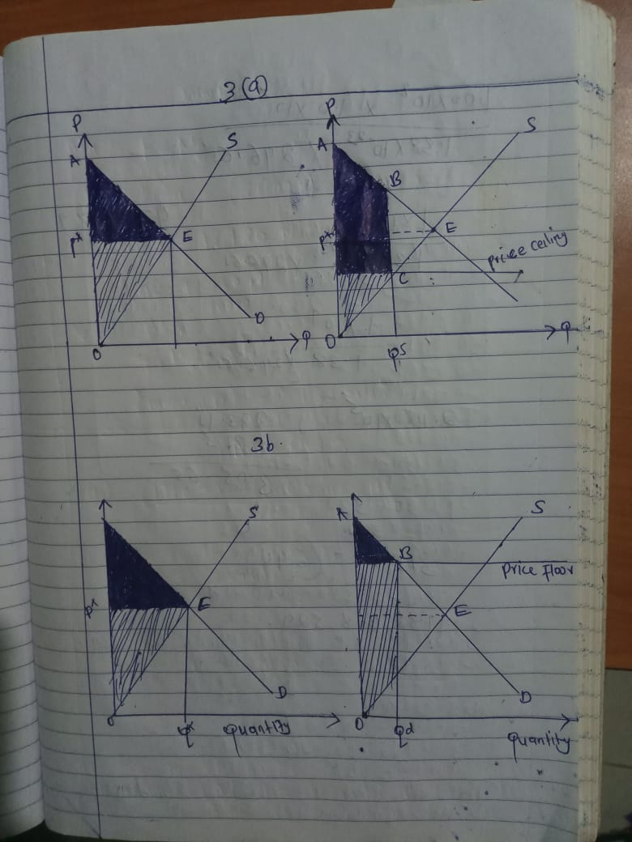

- Given the following information:
P = 20 – 2Q
MC = AC = 4

- Determine the profit-maximizing output and price charged by a monopolist.
R = PQ = 20Q - 2Q2
MR = dR/dQ = 20 - 4Q
MR = MC
20 - 4Q = 4
16=4q
Q=4
Pm = 12

- Determine the competitive price and output.
P = MC = AC:
20 - 2Q = 4
Qc = 8
Pc = 4

- Graphically illustrate and calculate the deadweight loss due to the monopoly.
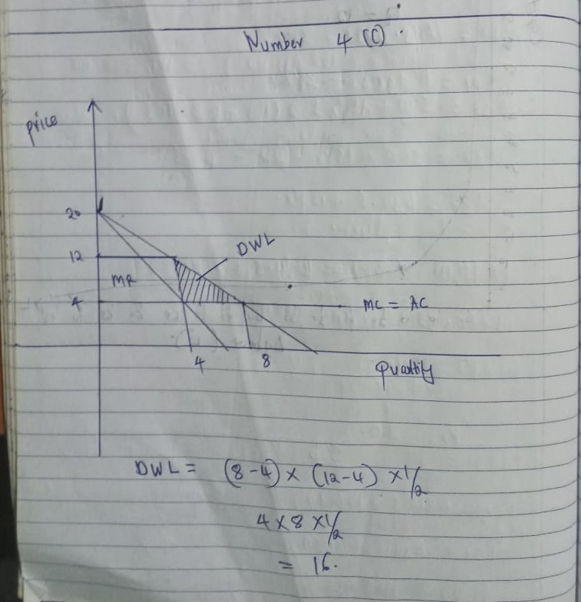

- Consider the following information for Rancher John:
TVC = 40q + q²
- If the market price is $150, calculate the output level for Rancher John in the short run.
Price = Marginal Cost
Marginal cost = dTVC/dQ = 40 +2Q
40+ 2Q = 150
2Q=110
Q=55

- If the total fixed cost is $8000, should Rancher John shut down or continue to produce in the short run? Explain your decision.

AVC= TVC/55
= [(40*55)+(55)^2]/55
= 95
Price = 150
Now, AFC= TFC/Q
= 8000/55
= 145 (approx)
AC= AVC+AFC
= 95+145
= 240
This shows that the firm is making loss, it should operate in short term to minims loss.

- Suppose that in a competitive market, the market demand for the product is expressed as P = 80 – 1.5Q, and the supply of the product is expressed as P = 26 + 0.50Q.

Price, P, is in dollars per unit sold, and Q represents the rate of production and sales in hundreds of units per day. The typical firm in this market has a marginal cost of
MC = 1.5 + 13.5Q.

(a) Determine the equilibrium market price and rate of sales.

Demand is given by p =80-1.5q
Supply is given by S = 26+0.50q
At equilibrium demand= supply
80-1.5q=26+0.5q
54=2q
Q= 27
P= 26 +0.5(27)
P=26+13.5
P= 39.5

- Determine the typical firm's rate of sales, given your answer to part (a) above.

39.5= 1.5 +13.5q
39.5-1.5 = 13.5q
38/13.5 = q
2.815= q

(c) If the market demand were to increase to P = 110 – 1.6Q, what would the new price and sales rate in the market be? What would the new rate of sales for the typical firm be?
New demand P=110-1.6q
Supply = 26+0.5q
110-1.6q= 26+0.5q
84=2.1q
84/2.1 = q
40=q
P= 26+0.5(40)
P= 26+20
P= 46
P=mc
46=1.5+13.5q
44.5=13.5q
44.5/13.5 = q
3.30 =q

- (a) Graphically illustrate and explain a firm engaging in intertemporal price discrimination.
Intertemporal price discrimination refers to the change of price to different customers in different periods. This strategy involves charging a different price to consumers based on willingness to pay. Intertemporal price discrimination occurs when consumer anticipates future price decline, thus low purchase during that period.

- Graphically illustrate and explain a firm engaging in peak-load pricing.
Peak-load pricing refers to charging products depending on the demand in the market. A good example of peak- load price is during the peak season. Some commodities are charged during the peak season. Some of the commodities and services charged high prices include transport, perishable goods, and electricity. The marginal cost of these commodities is high during peak time. 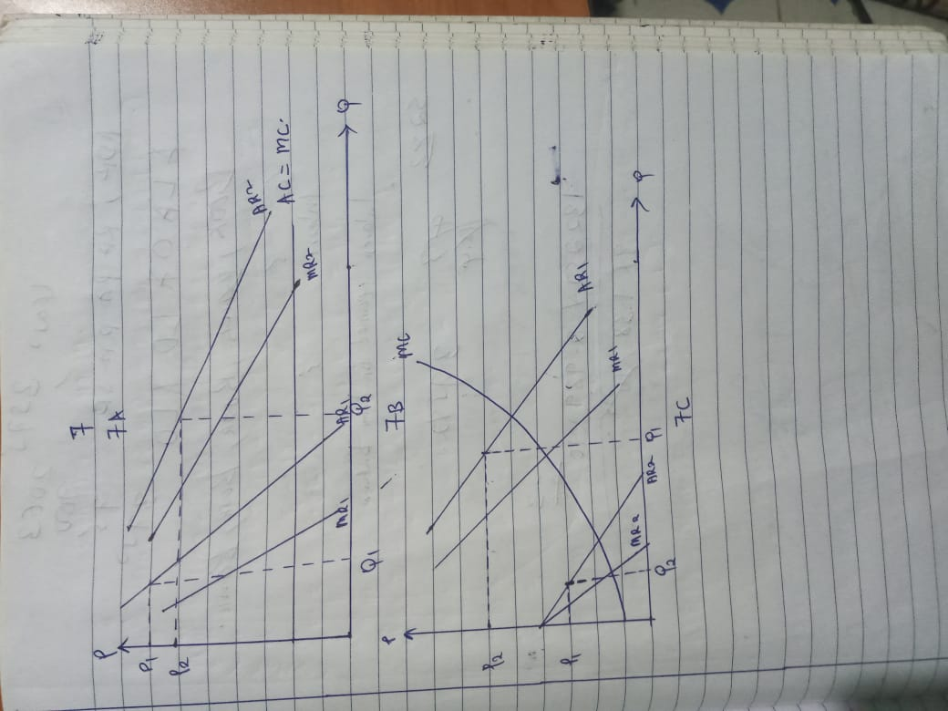

- A monopolist firm faces a demand with constant elasticity of -2.0. It has a constant marginal cost of $20 per unit and sets a price to maximize profit. If marginal cost increases by 25%, what would be the change in price level?

P=MC/(1+(1/e))
=20/(1+(1/(-2)) = 20/0.5 = 40
MC=20x0.25=25
P=25/(1+(1/(-2))
=50
the increase in P=(new P -old P)/old P
=(50-40)/40 = 10/40 = 0.25
=25%

- The table below contains information for Mom Pizza in the city of Saskatoon, SK. Mom Pizza is operating in a competitive market, has a fixed cost of $12, and sells only one pizza size for $15.
Total | VC | TC | MC | TR | MR | ATC | Profit
0 | 0 | 12 | - | 0 | - | - | -12
1 | 9 | 21 | 9 | 15 | 15 | 21 | -6
2 | 20 | 32 | 11 | 30 | 15 | 16 | -2
3 | 35 | 47 | 15 | 45 | 15 | 15.67 | -2
4 | 55 | 67 | 20 | 60 | 15 | 16.75 | -7
5 | 65 | 77 | 10 | 75 | 15 | 15.4 | -2
6 | 70 | 82 | 5 | 90 | 15 | 13.67 | 8
7 | 80 | 92 | 10 | 105 | 15 | 13.14 | 13
8 | 101 | 113 | 21 | 120 | 15 | 14.125 | 7
9 | 130 | 142 | 29 | 135 | 15 | 15.77 | -7
10 | 165 | 177 | 35 | 150 | 15 | 17.7 | -27
11 | 205 | 217 | 40 | 165 | 15 | 19.72 | -106
12 | 250 | 262 | 45 | 180 | 15 | 21.83 | -82

- Complete the TC, MC, ATC, TR, MR, and profit. (3 marks)

- Determine the profit-maximizing level of output and price. Justify your answer.
(1 mark)

- Edmonton Museum has hired you to assist them in setting new admission prices. The museum's managers recognize that there are two distinct demand curves for museum admission. One demand curve applies to adults, while the other is for senior citizens and children. The two demand and marginal revenue curves are:

P_{A} = 8.10 – 0.09Q_{A}
P_{C&S} = 4.10 – 0.10Q_{C&S}
MR_{A} = 8.10 – 0.18Q_{A}
MR_{CS} = 4.1 – 0.2Q_{C&S}

P_{A} = adult price, P_{C&S} = prices for children and seniors, Q_{A} = daily quantity of adults, and Q_{C&S} = daily quantity of children and senior citizens. Suppose crowding is not a problem at the museum so that the managers consider the marginal cost to be zero.

(a) If the museum decides to price discriminate, what are the profit-maximizing prices and quantities in each market? Calculate total revenue in each sub-market.

- What is the elasticity of demand at the quantities calculated in (a) for each market. Are these elasticities consistent with your understanding of profit maximization and the relationship between marginal revenue and elasticity?
